**Astronaut assistants CIMON**

Bibek Lamsal

CSE student from BVC Engineering College, Amalapuram, Andhra Pradesh

**Introduction:**

**CIMON** (Crew Interactive Mobile Companion) is AI based interactive robotic System used by ISS in the space to fulfil the loneliness, basic requirements like experiment procedure, suggestions, handling critical situation for astronauts.

In 2016, It was designed and developed by the partnership between Airbus, German space agency DLR, and IBM and later in 2018 Cimon leave the earth and went to the ISS.

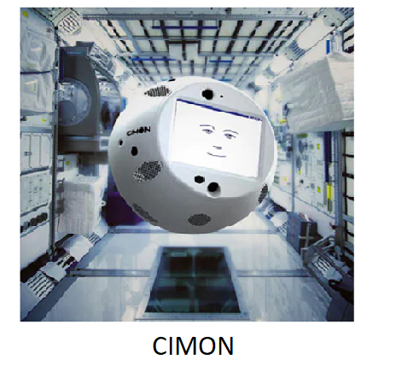

**Design and Related Features of Cimon:**

Cimon looks like spherical in shape and weighs 5 Kilograms.

Cimon is designed in a way that it will able to fly around its space station environment using a system where it sucks in air and then expels it through special tubes.

More impressively the bot is capable of interacting in somewhat complex ways with humans, even being able to identify who it is conversing. This makes possible by facial recognition software. Along with this Cimon does, in fact, have a face of its own, all be it is a very simple cartoon one incapable of complex expression.

**Working Mechanism of Cimon:**

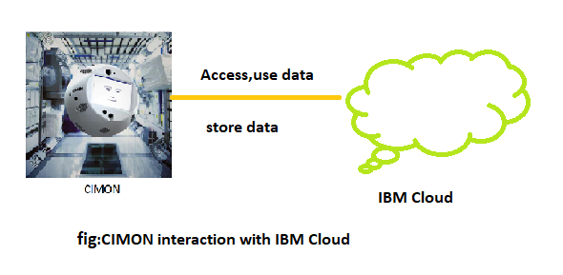

Cimon is connected to the IBM cloud for store, access, use the data. Infect the data gather by the Cimon in the space can be transferred into the IBM cloud and IBM Cloud provides the environment where Cimon can learn, make decision. Which makes the Cimon smarter and more useful day by day in the space.

**Success of Cimon:**

When travelling to the Moon or Mars, the crew would then be able to rely on an AI-based assistance **Cimon’s** service, even without a permanent data link to Earth. One application back on Earth could be to support people with complex tasks in areas with poor infrastructure, for example. IBM is responsible for the implementation of Cimon’s artificial intelligence. During its first deployment on the ISS, Cimon proved that ‘’it cannot only understand content in context, but also the intention behind it’’.

**Future of Cimon:**

The IBM project lead for CIMON is Biniok, who said “We can’t really talk about the next steps yet, but I can tell you about our vision. In my mind, the goal is to create a real astronaut companion, a real assistant that is helping, not just on the ISS, but on other space stations, maybe on journeys to the moon and Mars and beyond — that’s the long-term vision. They will definitely need some AI to accomplish those journeys.”

**Summary:**

**CIMON** (Crew Interactive Mobile Companion) is a specially designed and developed for the astronauts to make them more productive, less depressed, less lonely, gives sign and necessary alarms in perfect time, helps in critical and complex procedure, and to explore the space in efficient way.

On 15 November 2018, Cimon-1 became the world’s first AI to be deployed on the ISS. Cimon have been doing amazing job in the ISS. And other space station also requires this type of assistance. Which is worth for the use of basic to the complex experiment, research in the space.

**References:**

<http://www.robotsvoice.com/cimon-first-artificial-intelligence-space/>

<https://www.ibm.com/thought-leadership/innovation-explanations/cimon-ai-in-space>